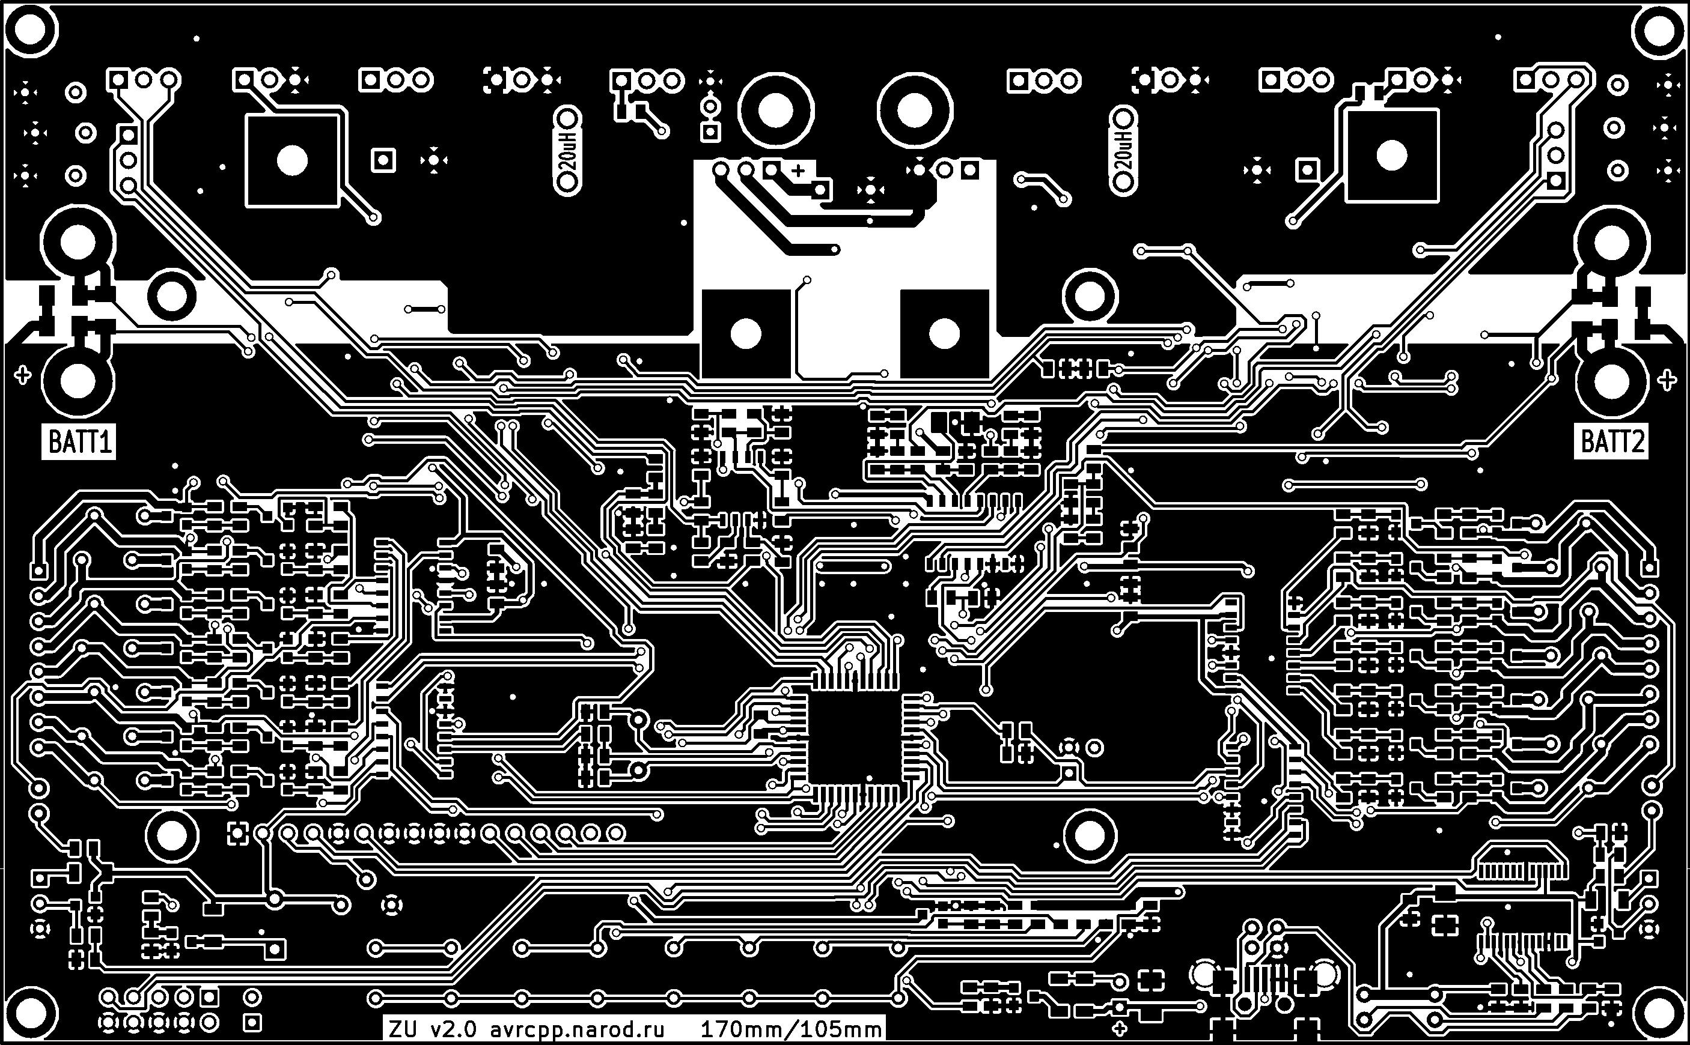

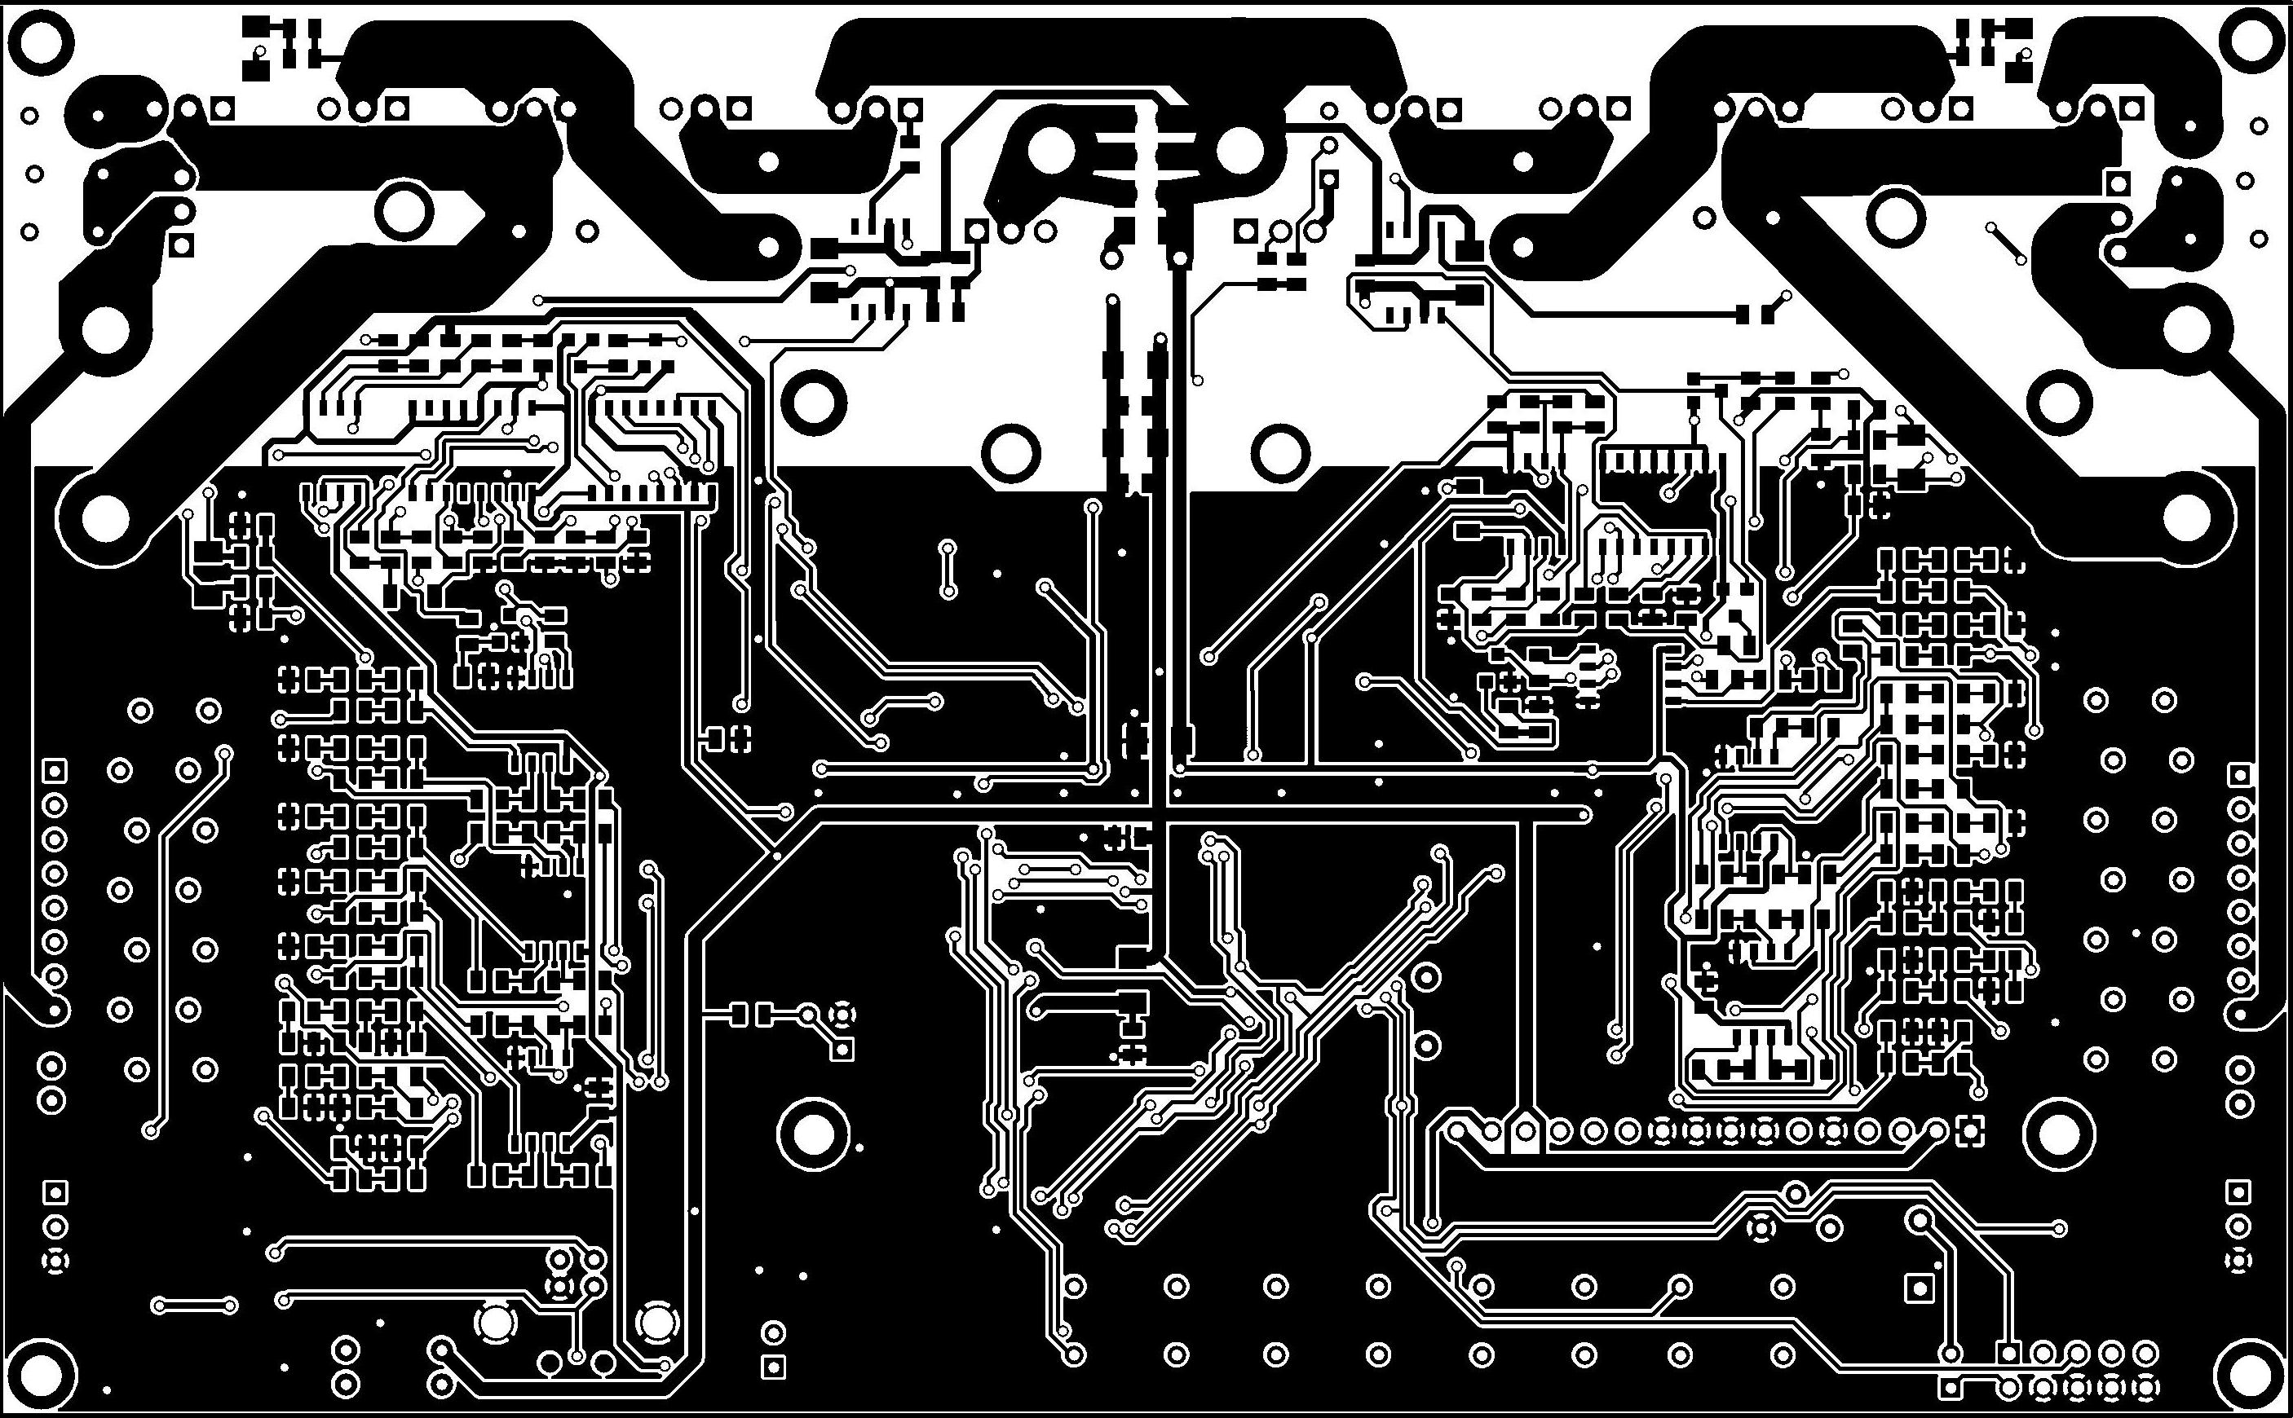

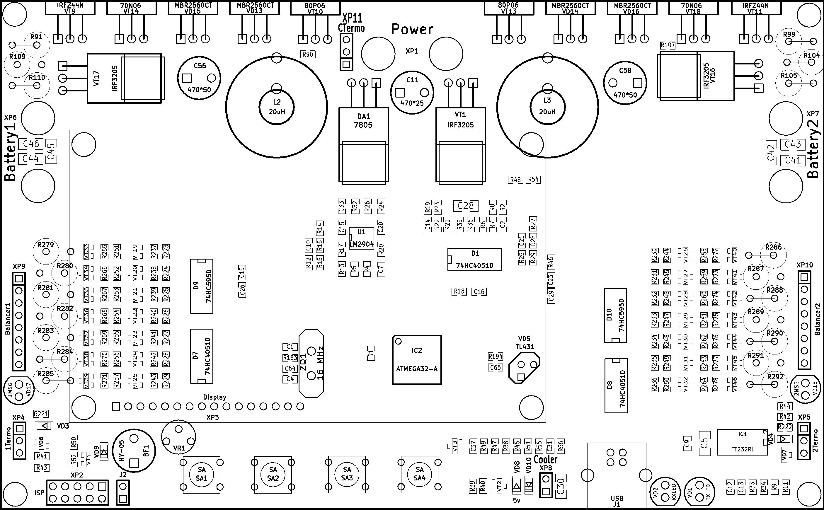

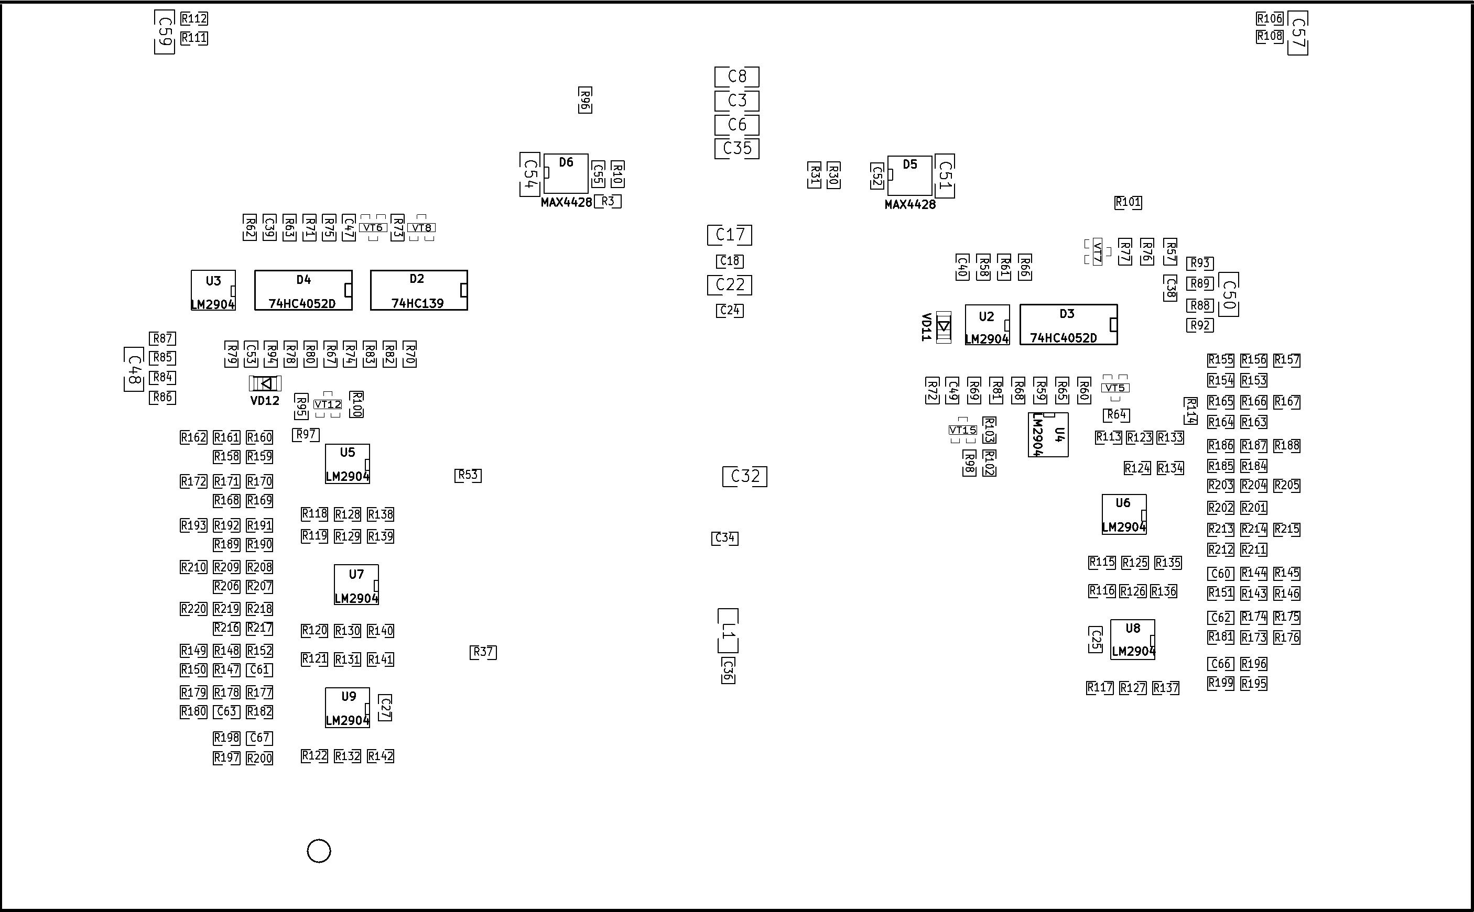

Номинал | Кол-во | Корпус | Обозначение | Описание
ATMEGA32-A | 1 | TQFP44 | IC2
FT232RL | 1 | SSOP28 | IC1
MT-20S4A | 1 | 16pin | XP3
IRF3205 | 3 | TO220 | VT1, VT16, VT17
74HC4051D | 3 | SO16N | D1, D7, D8
74HC595D | 2 | SO16N | D9, D10
74HC139 | 1 | SO16N | D2
74HC4052D | 2 | SO16N | D3, D4
LM2904 | 9 | SO8N | U1, U2, U3, U4, U5, U6, U7, U8, U9
IR4428 или MAX4428 | 2 | SO8N | D5, D6
7805 | 1 | TO220 | DA1
80P06 | 2 | TO220 | VT10, VT13
70N06 | 2 | TO220 | VT14, VT18
IRFZ44N | 2 | TO220 | VT9, VT11
BC847 | 21 | SOT23 | VT2, VT3, VT4, VT7, VT8, VT12, VT15, VT19, VT20, VT21, VT22, VT23, VT24, VT25, VT26, VT27, VT28, VT29, VT30, VT31, VT32
BC857 | 2 | SOT23 | VT5, VT6
BCV26 | 14 | SOT23 | VT33, VT34, VT35, VT36, VT37, VT38, VT39, VT40, VT41, VT42, VT43, VT44, VT45, VT46
MBR2560CT | 4 | TO220 | VD13, VD14, VD15, VD16
LL4148 | 6 | SOD80 | VD3, VD4, VD9, VD10, VD11, VD12
5v | 1 | SOD80 | VD8
BAT54S | 2 | SOT23 | VD6, VD7
TXLED, RXLED, 1MSG, 2MSG | 1 | LED5MM | VD1, VD2, VD17, VD18
TL431 | 1 | TO92 | VD5
Battery1, Battery2 | 2 | KLEMMA2 | XP6, XP7
Power | 1 | KLEMMA2 | XP1
1Termo, 2Termo, CTermo | 3 | 3pin (LM35) | XP4, XP5, XP11
Balancer1, Balancer2 | 2 | 8pin | XP9, XP10
Cooler | 1 | 2pin | XP8
ISP | 1 | 5x2pin | XP2
JMP | 1 | 2pin | J2
USB | 1 | USB_B | J1
SA | 4 | SW_PUSH | SA1, SA2, SA3, SA4
HY-05 | 1 | HY-05 | BF1
QUARTZ 16MHz | 1 | HC-18UV | ZQ1
20uH | 2 | DROSSEL | L2, L3
10uH | 1 | _1206 | L1
470*25 | 1 | C2V8 | C11
470*50 | 2 | C2V8 | C56, C58
4,7 | 19 | _1206 | C3, C5, C6, C8, C17, C22, C28, C32, C35, C41, C42, C43, C44, C45, C46, C48, C50, C51, C54
2,2 | 1 | _1206 | C30
1,0_ | 2 | _1206 | C57, C59
0,22 | 1 | _0805 | C37
0,15 | 4 | _0805 | C15, C33, C40, C47
0,1 | 32 | _0805 | C2, C7, C9, C10, C12, C13, C14, C18, C19, C20, C21, C23, C24, C25, C26, C27, C29, C31, C34, C36, C38, C39, C49, C52, C53, C55, C60, C61, C62, C63, C66, C67
370 | 3 | _0805 | C16, C64, C65
27 | 2 | _0805 | C1, C4
47k | 1 | VARIABLE | VR1
750k | 2 | _0805 | R251, R258
620k | 2 | _0805 | R252, R259
510k | 2 | _0805 | R253, R260
499k | 20 | _0805 | R113, R114, R115, R116, R117, R118, R119, R120, R121, R122, R154, R159, R164, R169, R185, R190, R202, R207, R212, R217
390k | 2 | _0805 | R254, R261
249k | 20 | _0805 | R123, R124, R125, R126, R127, R128, R129, R130, R131, R132, R155, R160, R165, R170, R186, R191, R203, R208, R213, R218
240k | 2 | _0805 | R255, R262
200k | 25 | _0805 | R3, R6, R14, R21, R27, R84, R85, R88, R89, R143, R147, R265, R266, R267, R268, R269, R270, R271, R272, R273, R274, R275, R276, R277, R278
100k | 22 | _0805 | R46, R48, R53, R54, R60, R65, R68, R70, R72, R74, R78, R80, R173, R174, R177, R178, R195, R196, R197, R198, R256, R263
68k | 2 | _0805 | R144, R148
51k | 1 | _0805 | R55
47k | 2 | _0805 | R86, R92
33k | 2 | _0805 | R87, R93
20k | 1 | _0805 | R51
18k | 5 | _0805 | R7, R15, R22, R28, R35
10k | 72 | _0805 | R4, R13, R20, R26, R30, R31, R39, R40, R41, R42, R43, R44, R47, R49, R50, R52, R57, R59, R62, R64, R67, R69, R73, R79, R95, R97, R98, R102, R133, R134, R135, R136, R137, R138, R139, R140, R141, R142, R151, R152, R181, R182, R199, R200, R223, R224, R225, R226, R227, R228, R229, R230, R231, R232, R233, R234, R235, R236, R237, R238, R239, R240, R241, R242, R243, R244, R245, R246, R247, R248, R249, R250,
7,5k | 1 | _0805 | R45
5,1k | 5 | _0805 | R1, R9, R11, R38, R56
4,7k | 3 | _0805 | R10, R76, R82
3,3k | 2 | _0805 | R100, R103
3k | 2 | _0805 | R257, R264
2,7k | 1 | _0805 | R36
2k | 2 | _0805 | R61, R71
1,5k | 4 | _0805 | R5, R24, R214, R219
1,2k | 4 | _0805 | R77, R83, R204, R209
1k | 4 | _0805 | R58, R63, R81, R94
910 | 2 | _0805 | R187, R192
680 | 2 | _0805 | R175, R179
620 | 4 | _0805 | R145, R149, R166, R171
470 | 1 | _0805 | R37
330 | 2 | _0805 | R156, R161
300 | 15 | _0805 | R17, R18, R32, R33, R34, R66, R75, R106, R108, R111, R112, R183, R194, R221, R222
180 | 2 | _0805 | R16, R29
22 | 4 | _0805 | R12, R25, R157, R162
10 | 4 | _0805 | R90, R96, R101, R107
0 | 26 | _0805 | R2, R8, R19, R23, R146, R150, R153, R158, R163, R167, R168, R172, R176, R180, R184, R188, R189, R193, R201, R205, R206, R210, R211, R215, R216, R220
22 | 14 | 2w | R279, R280, R281, R282, R283, R284, R285, R286, R287, R288, R289, R290, R291, R292
0,5 | 2 | 2w | R91, R99
0,1 | 4 | 2w | R104, R105, R109, R110

